QR Based Food Ordering System

This project designed for restaurant owners and customers/users where restaurants owners can signup with the application and then login and then execute following modules

1. Add Chairs: using this module they can add some details about their restaurant environment
2. Create Menu: using this module they will create menus and all menus will linked with restaurant owner QR code. If any customer scan QR code then this restaurant menu will appear
3. View Menus: using this module owners can view menu details with QR code and menu image
4. View Orders: using this module they can view all orders coming from customers

Customers/user also has to signup and login to application and after login can execute below modules

1. View Restaurants: using this module all users can view all available restaurants and download their QR codes
2. Scan QR Codes: user has to download QR codes and then load or transfer to their mobile using Bluetooth and then can scan that QR code from their mobile to get menu. After seeing menu they can book desire item
3. View Bills: after making order they can view bills

To run project install python 3.7 and then install below packages by opening command prompt and execute below commands

Pip install Django==2.1.7

Pip install PyQRCode==1.2.1

Pip install PyMySQL==0.9.3

Now install MYSQL and give password as root and then copy content from ‘DB.txt’ file and paste in MYSQL console and then double click on ‘run.bat’ file to start DJANGO python server and then open browser and enter URL as ‘http://127.0.0.1:8000/index.html’ and press enter key to get below page

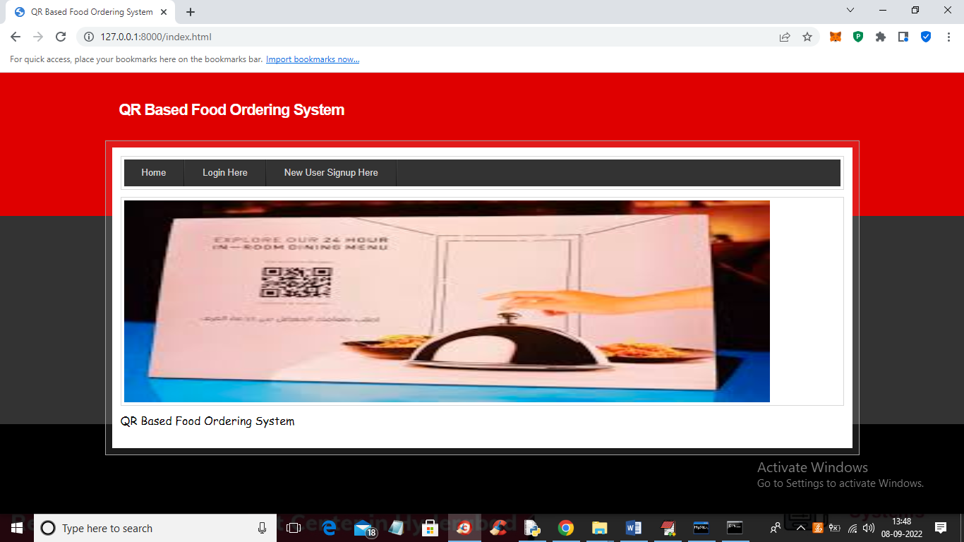

In above screen click on ‘New User Signup Here’ link to register restaurant owner or user

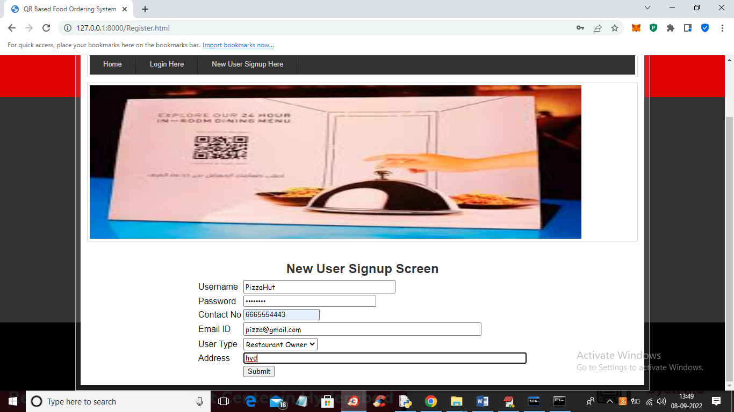

In above screen I am entering Restaurant owner details and then press button to complete signup process and get below output

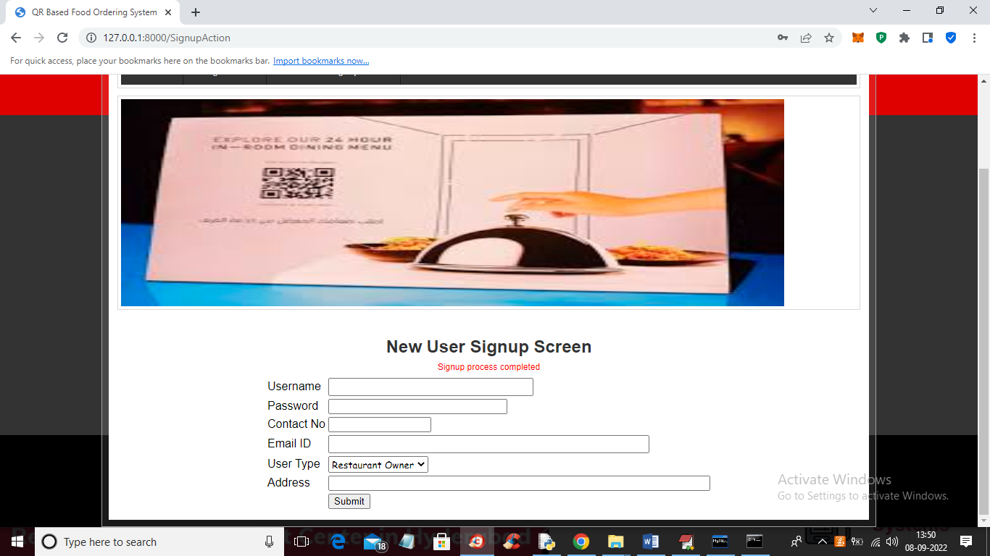

In above screen in red colour text we got response as signup completed and now add normal customer like below screen

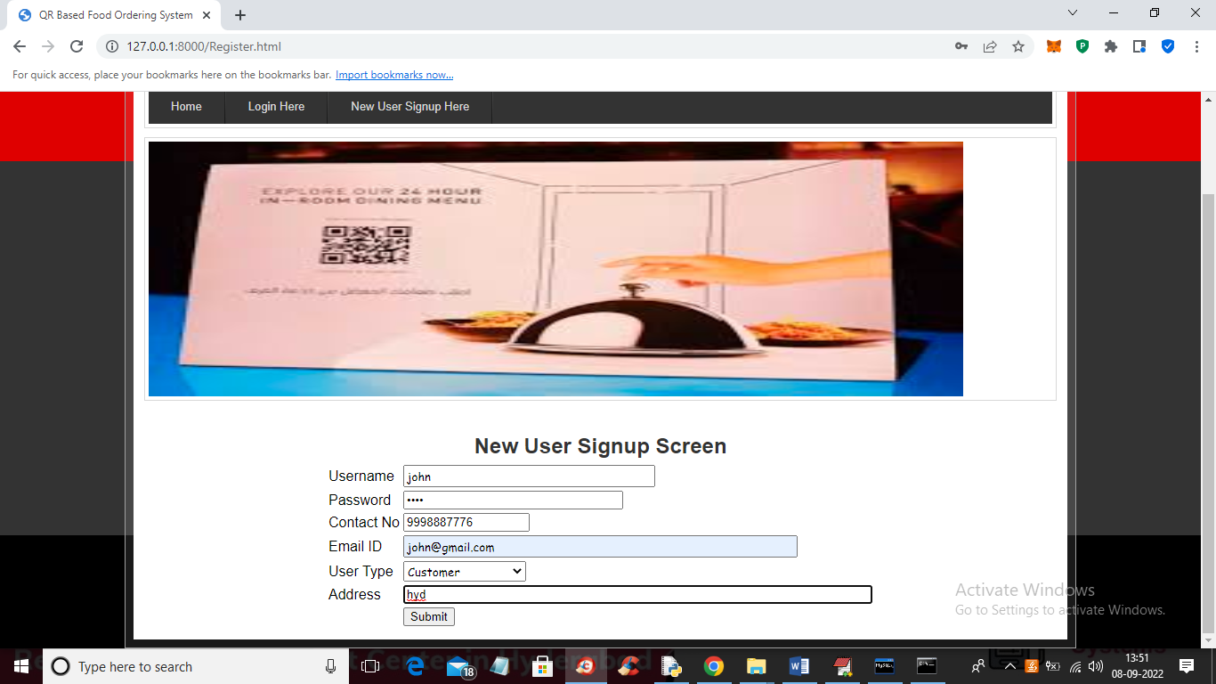

In above screen I am adding customer details and then press button to get below output

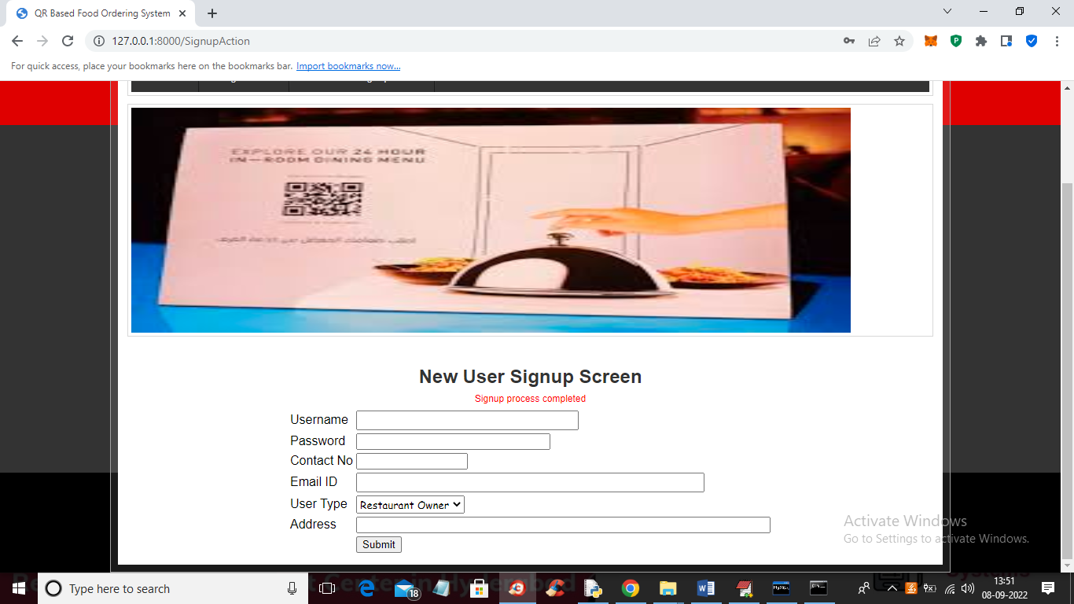

In above screen we can see customer details added and now click on ‘Login Here’ link to login restaurant owner

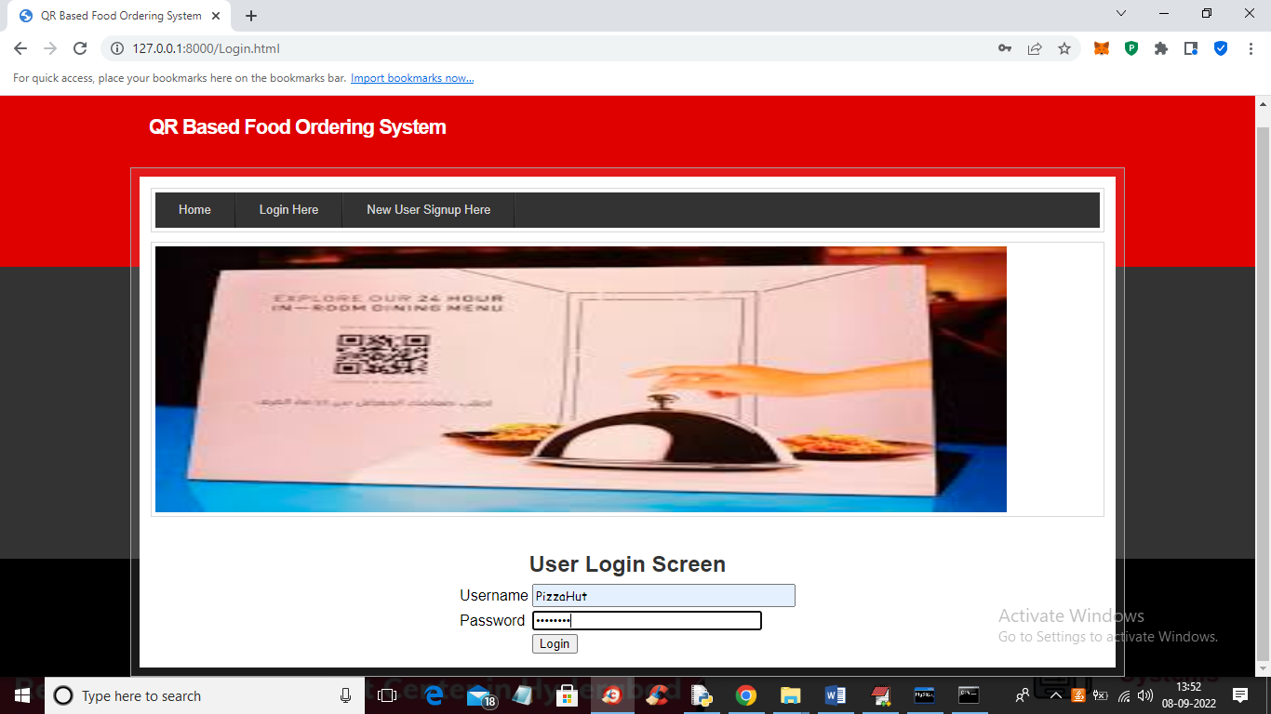

In above screen restaurant owner is login and after login will get below output

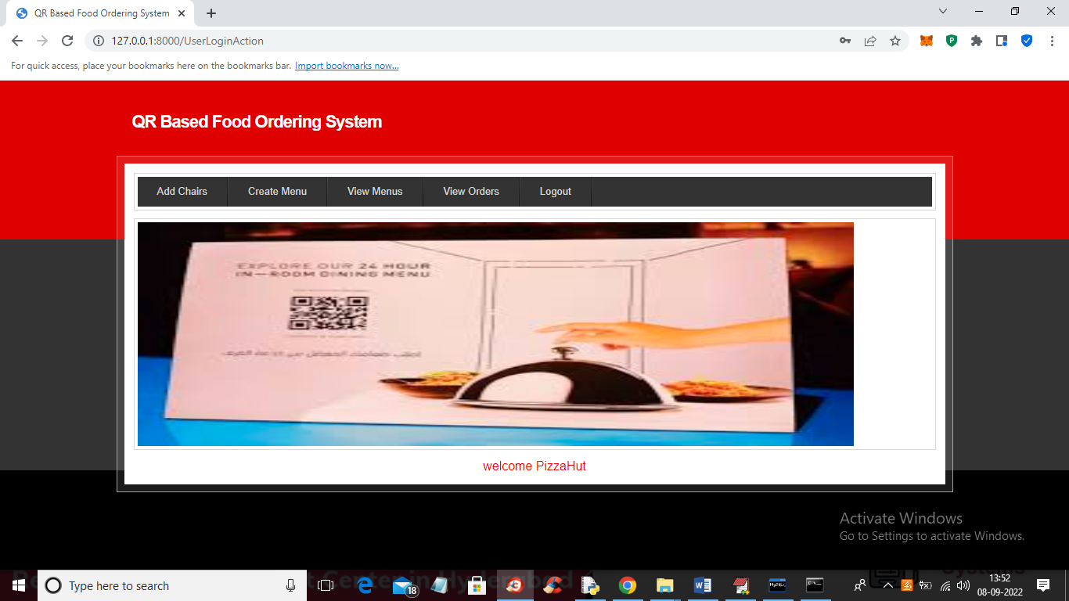

In above screen click on ‘Add Chairs’ link to add restaurant details

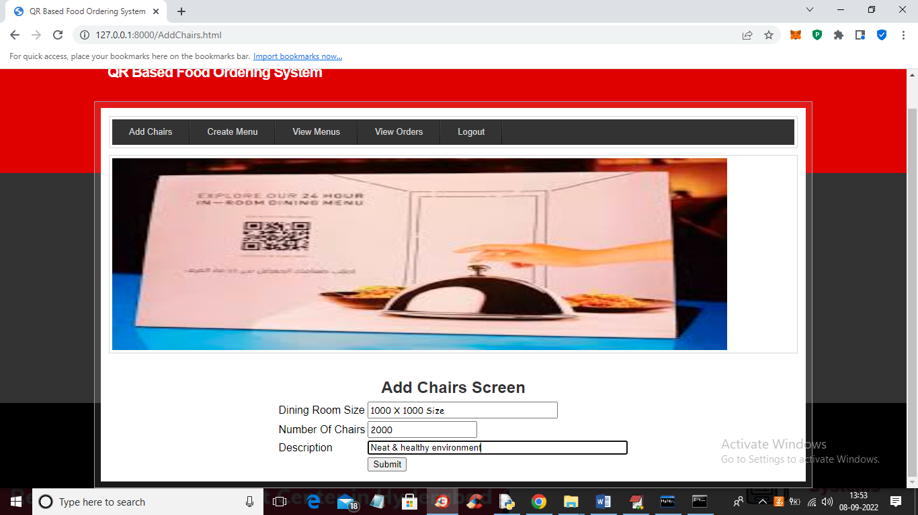

In above screen owner can add restaurant environment details and now press button to add details and get below output

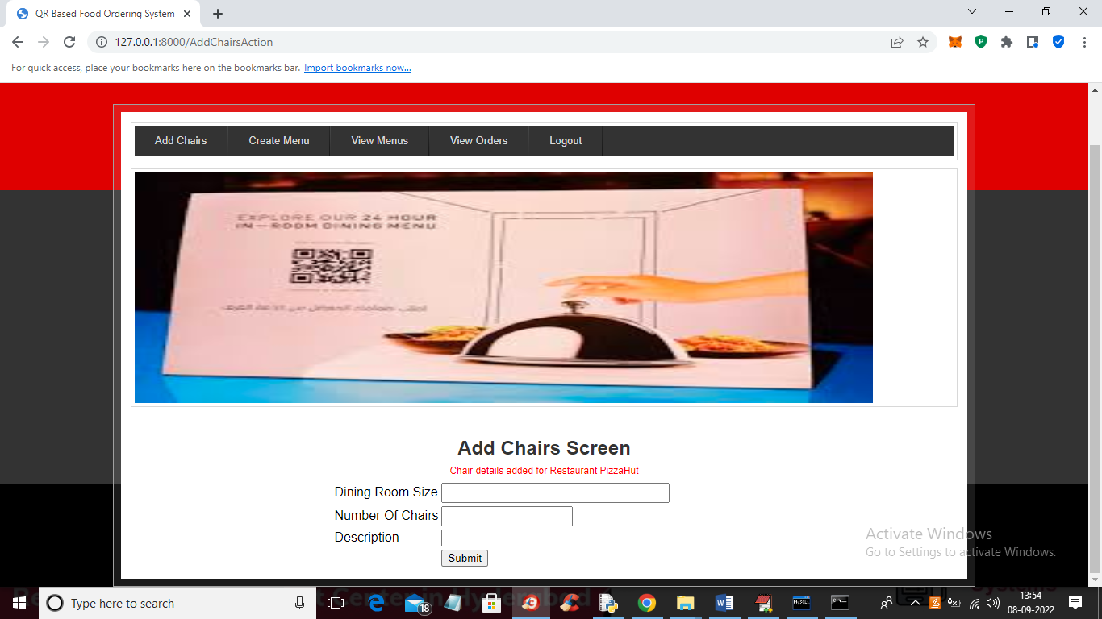

In above screen chairs details added and now click on ‘Create Menu’ link to add menu details

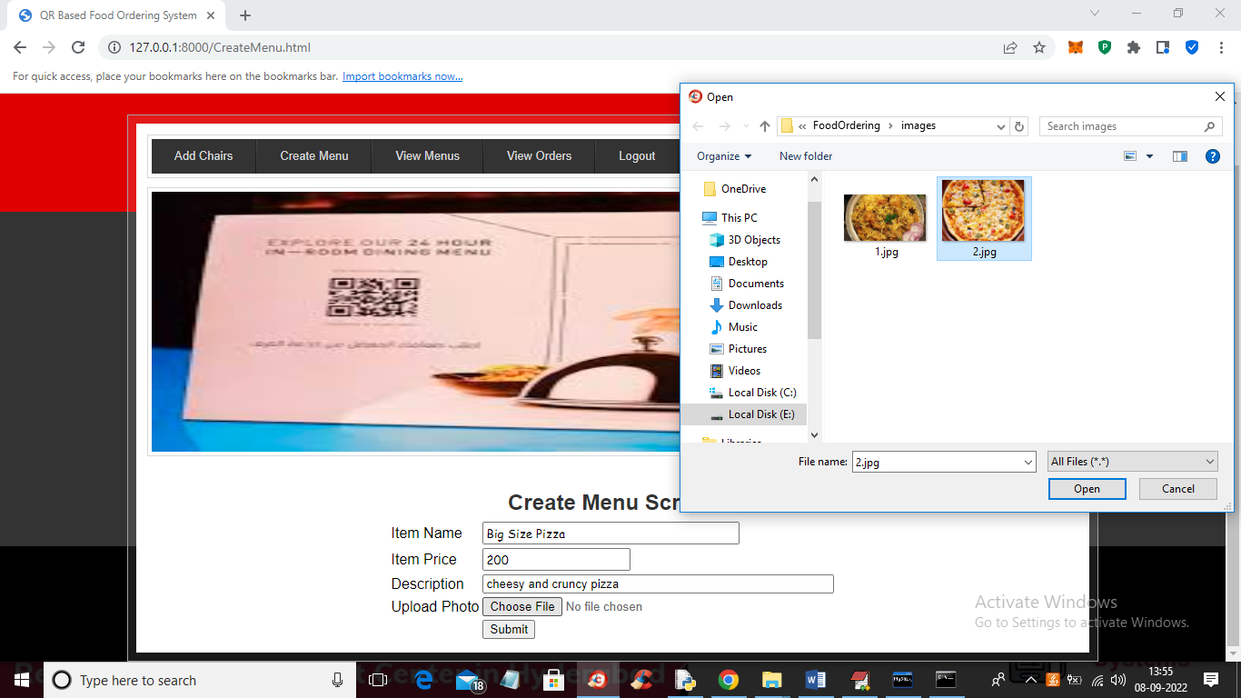

In above screen owner can add item menu details and then upload related image and then press button to get below output

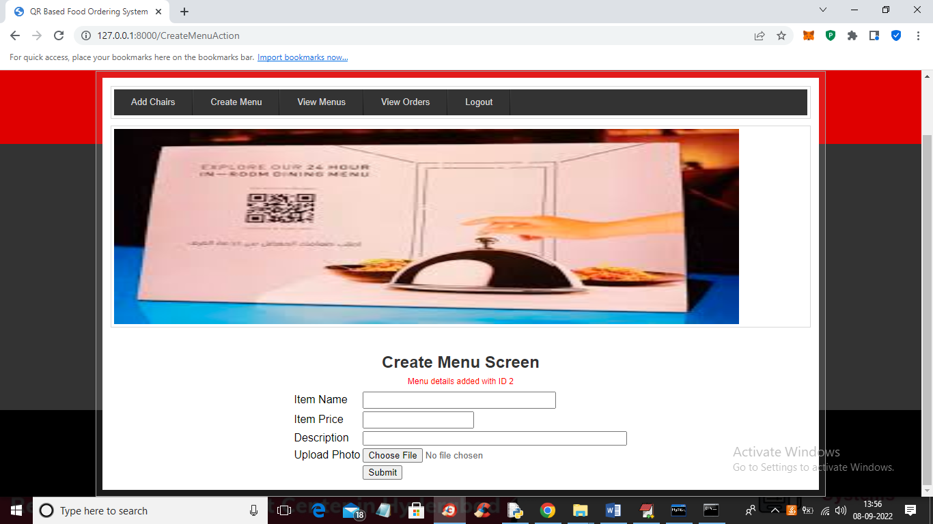

In above screen in red colour text we can see item details added with ID 2 and now click on ‘View Menus’ link to view all menus added by owner

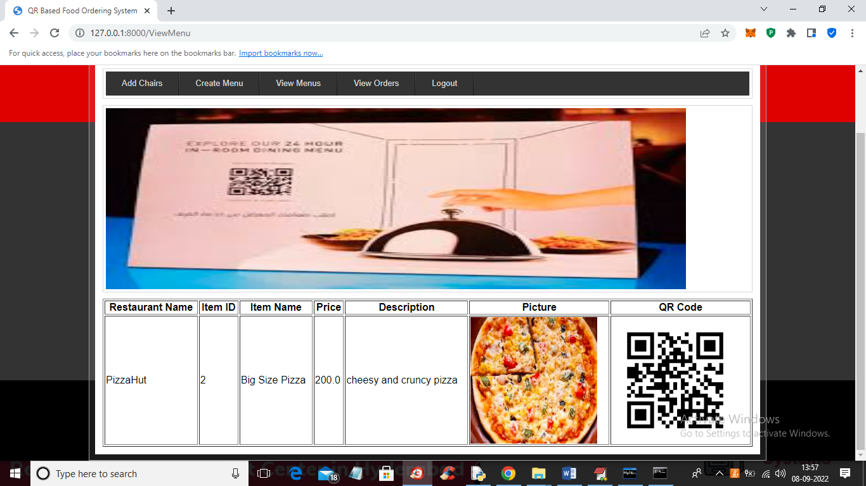

In above screen owner can view all menu details with QR code and now click on ‘View Orders’ link to view past orders came from customers

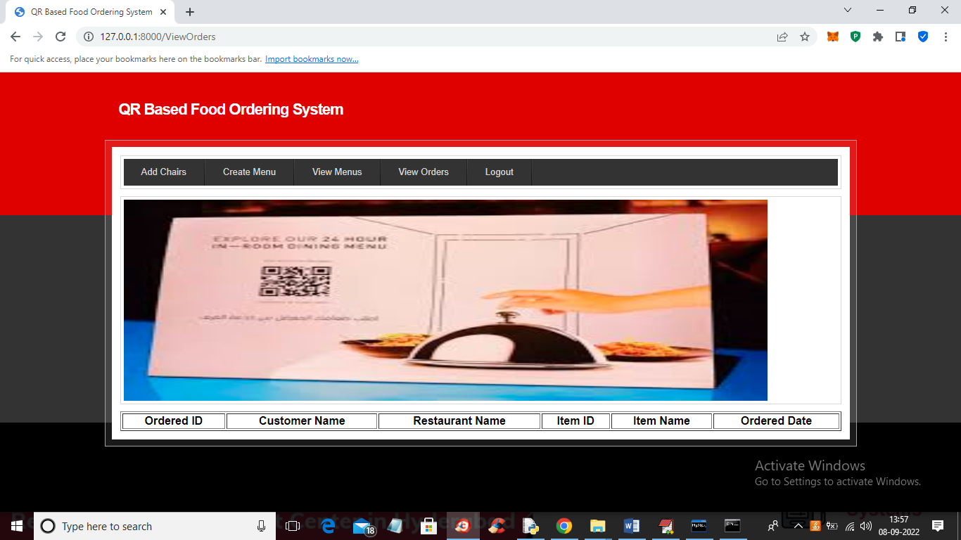

In above screen no orders are displaying and once customer booked any order then will get all order details in above screen. Now logout and login as ‘customer’ to get below output

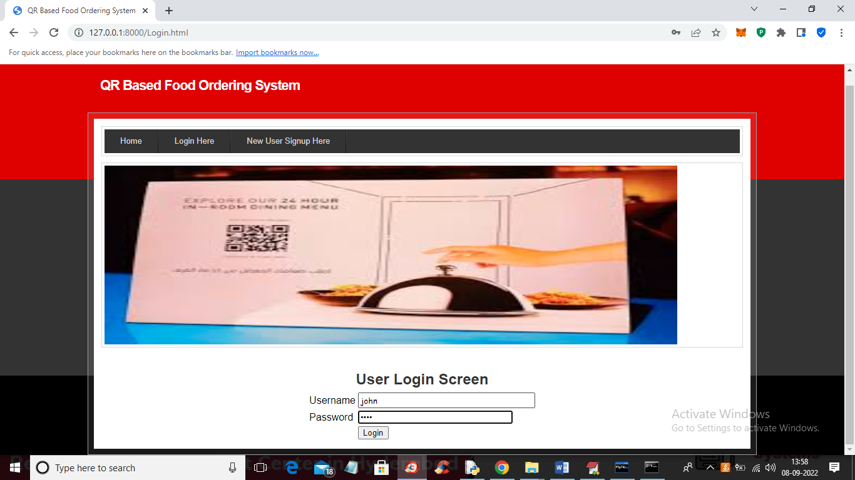

In above screen customer is login and after login will get below output

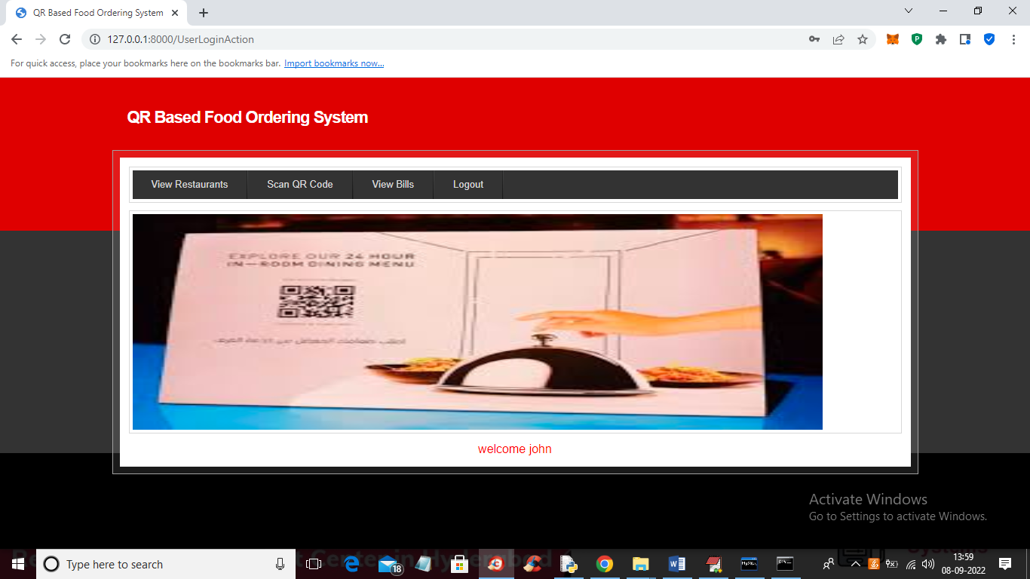

In above screen customer can click on ‘View Restaurants’ link to view all restaurants details like below screen

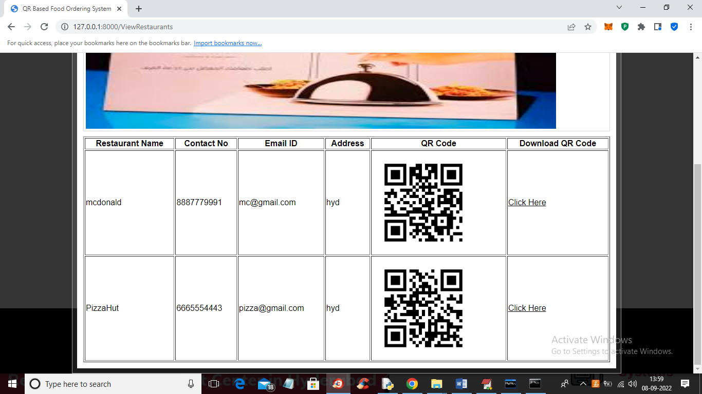

In above screen customer can view all restaurants details with QR code and now click on ‘Click Here’ on desired restaurant row to download QR code and then scan that QR code from their mobile like below screen

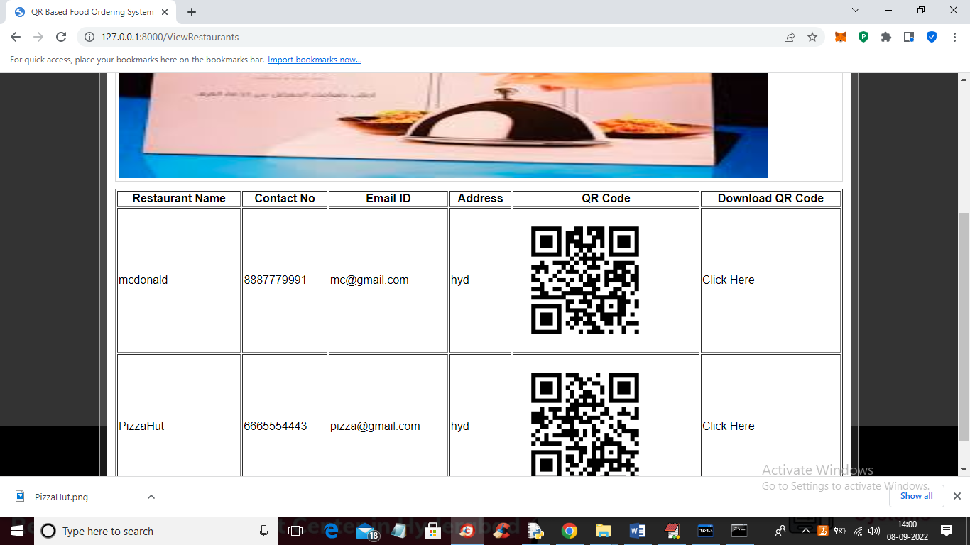

In above screen in browser status bar we can see QR code downloaded and now transfer that QR code to your mobile through Bluetooth like below screen

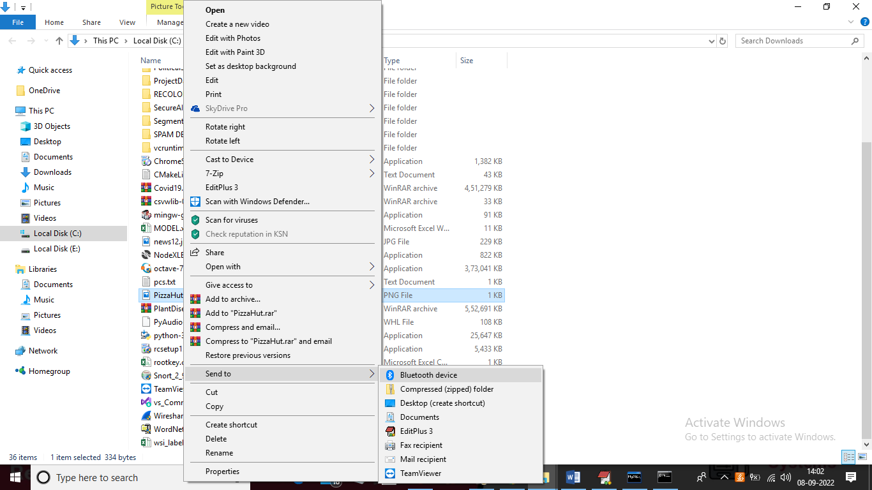

Using above screen I am sending QR code to mobile and now click on ‘Scan QR Code’ link to get below screen

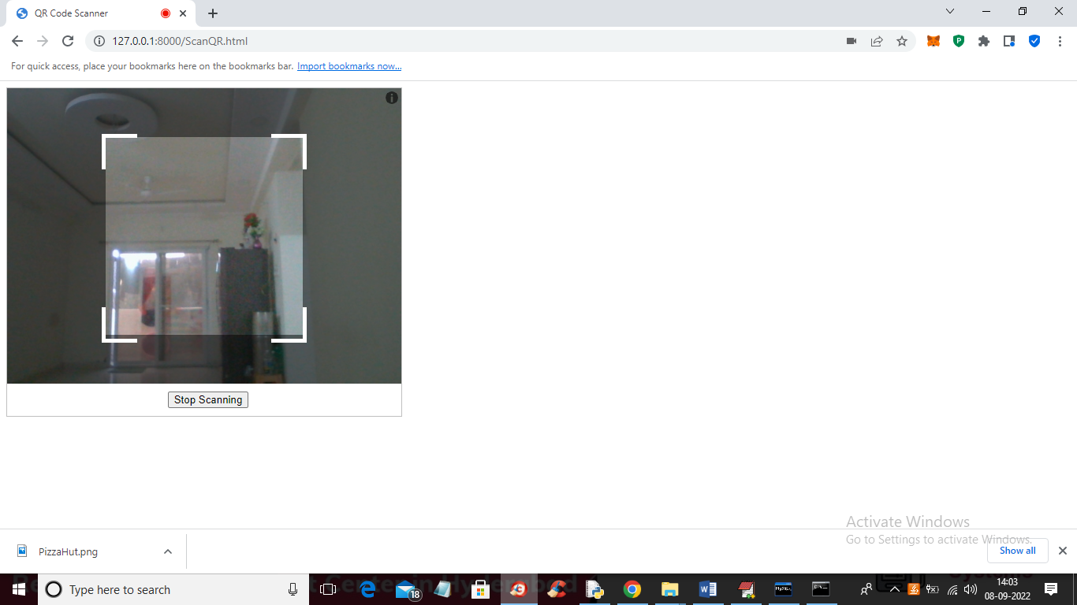

In above screen QR code reader is ready and now show QR code to get menu details like below screen

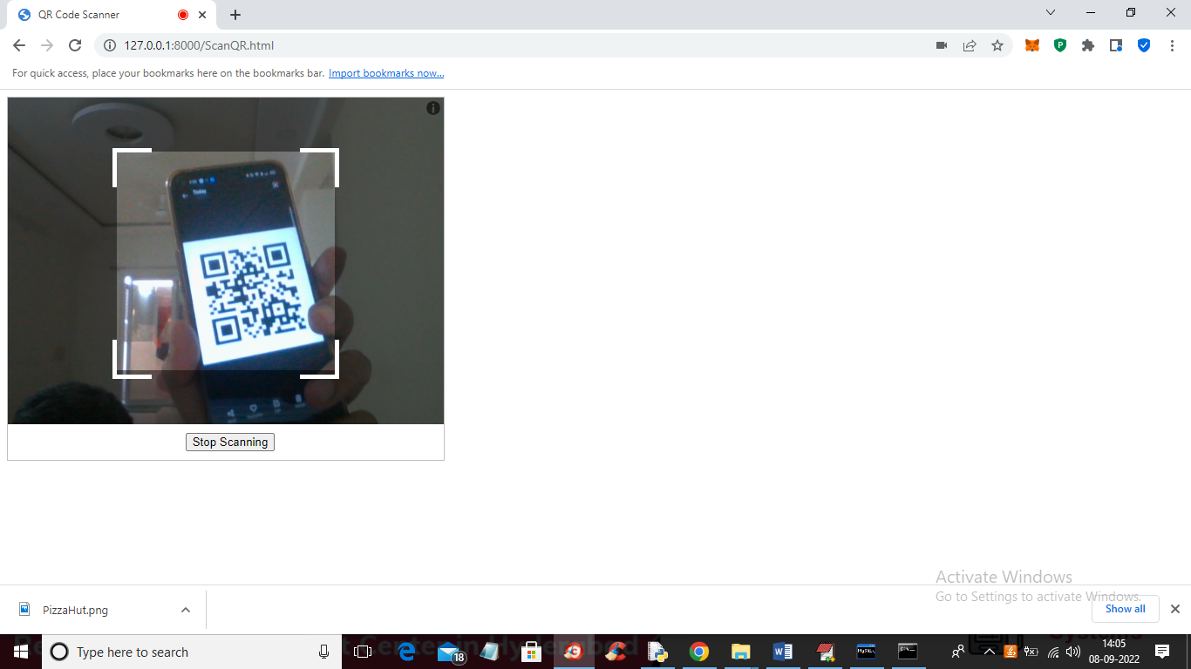

In above screen showing QR code from mobile and once code RECOGNIZED then will get below MENU details

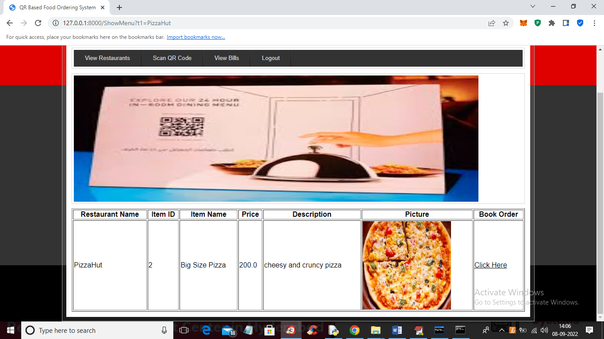

In above screen customer got menu details and now click on ‘Click Here’ link to BOOK ORDER and get below output

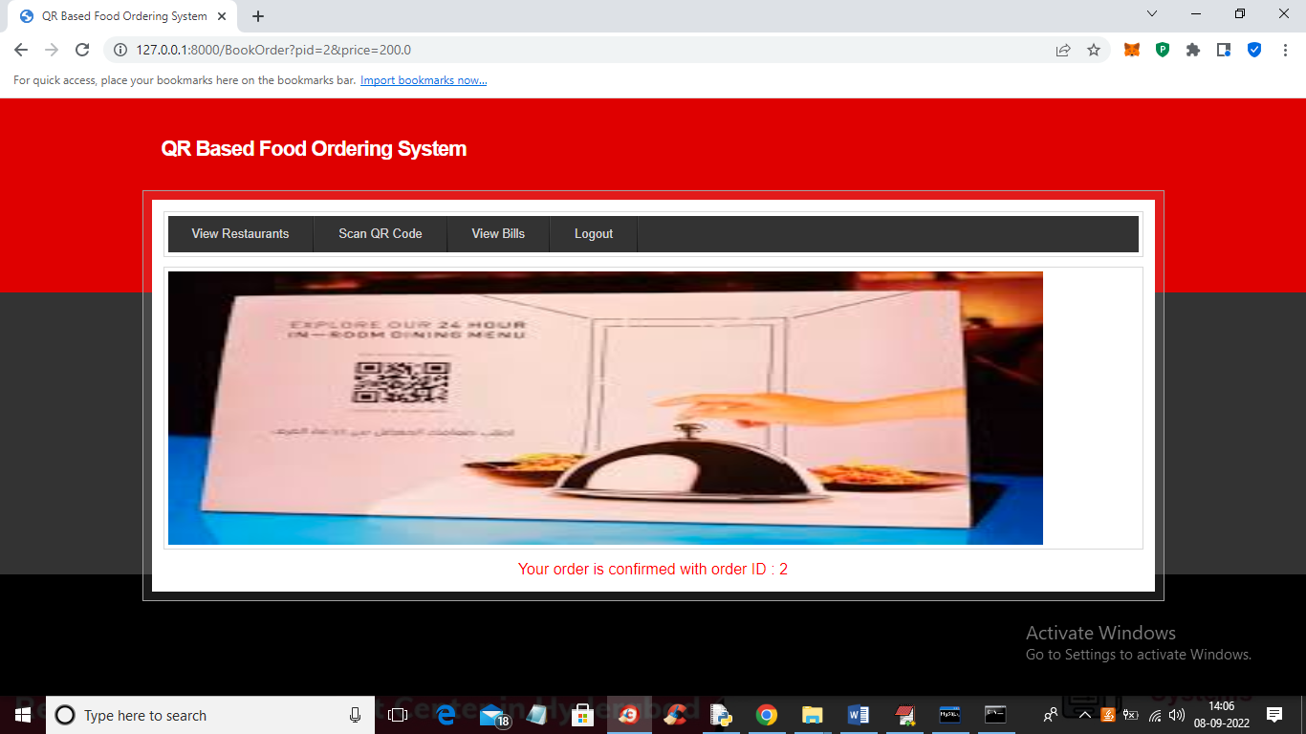

In above screen in red colour text we can see order is confirmed with ordered ID 2 and now click on ‘View Bills’ to view bill details

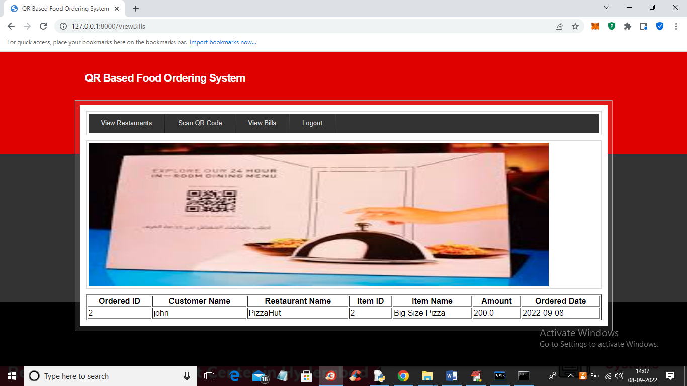

In above screen customer can view his order and bill details.

Similarly you can add any number of restaurant owner, menus and customers and can SCAN QR code and make booking